David Joffe – CCC presentation to the TUSDAC meeting September 2021
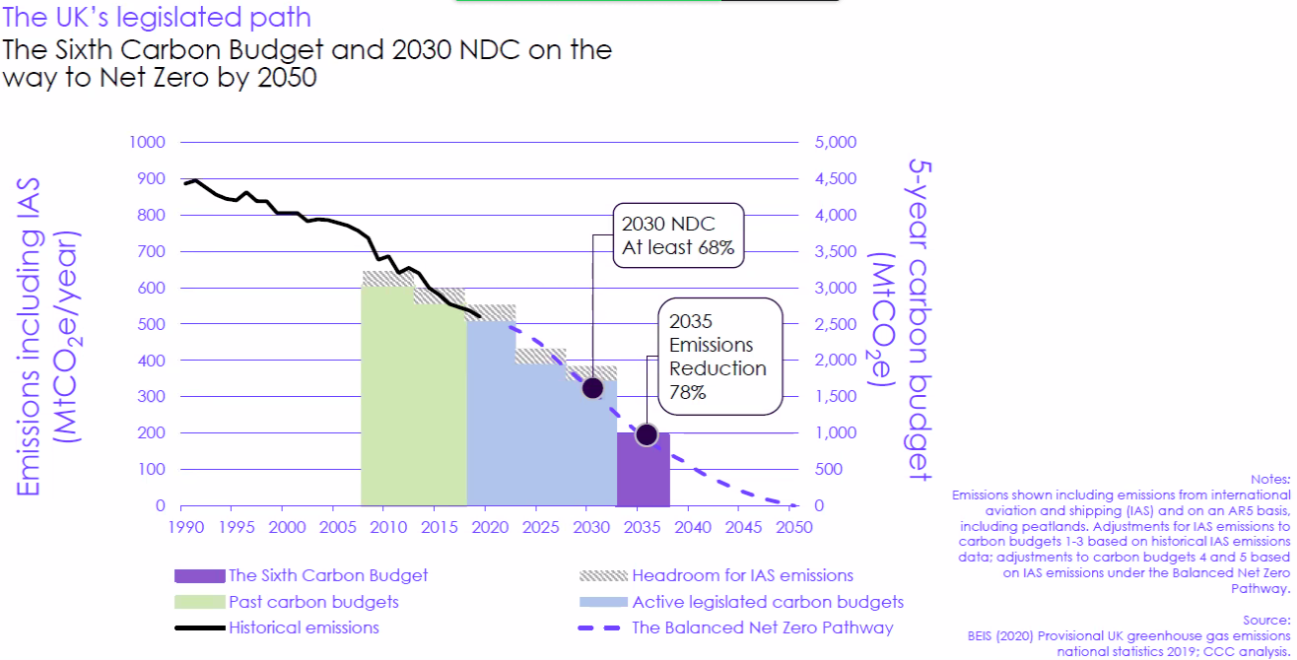

The governments been good in committing to the budgets the devil is in the detail
This is the central balanced approach to net zero.
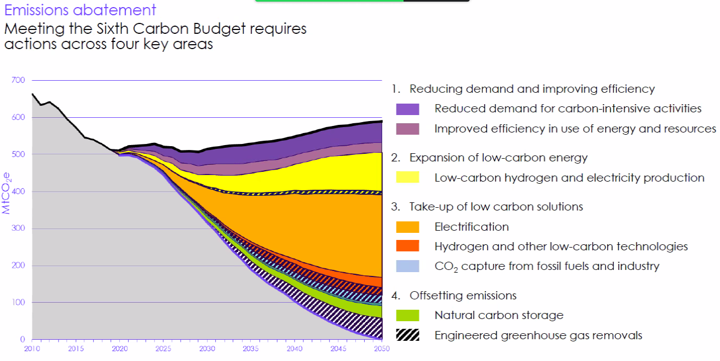
Still have methane coming out of Agriculture and there will still be emissions from aviation
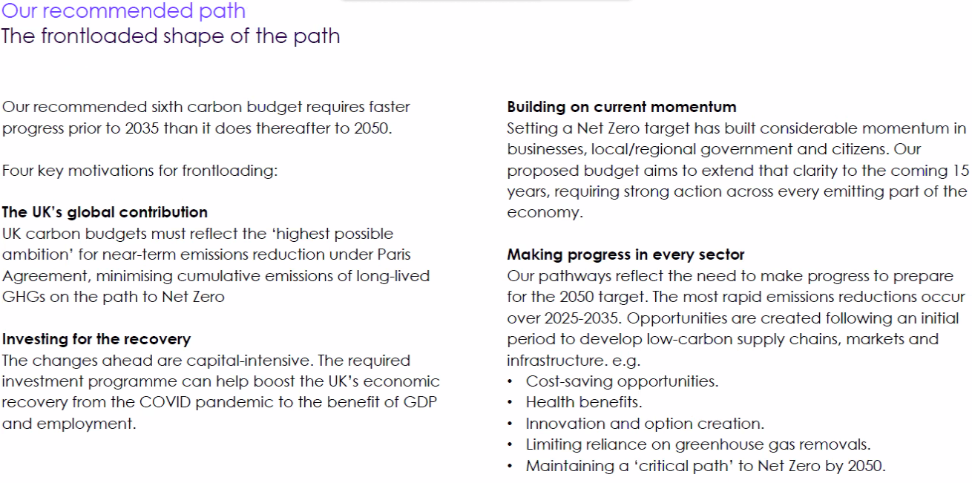
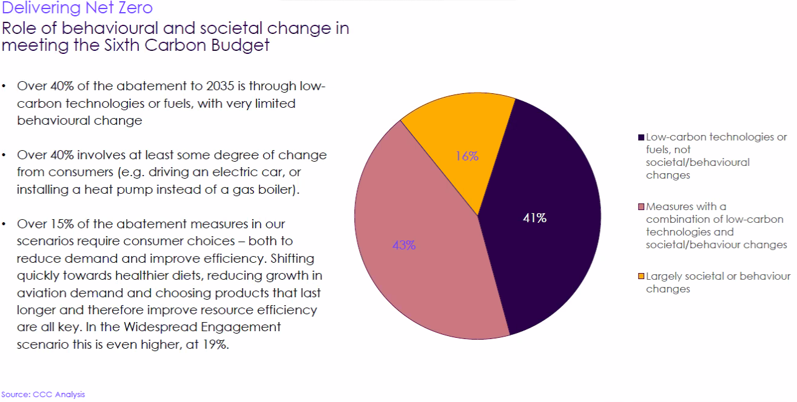
Making a behaviour change, other behaviour includes eating less red meat, cycling rather than driving etc.
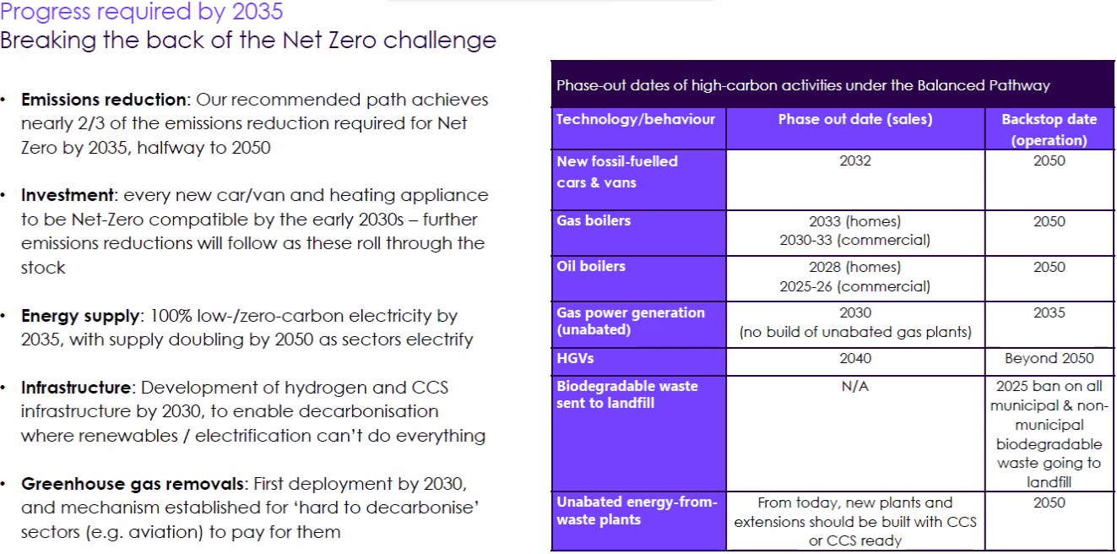
New Gas and oil boilers phased out in 2033 and 28 respectively.
£50 billion a year investment needed.
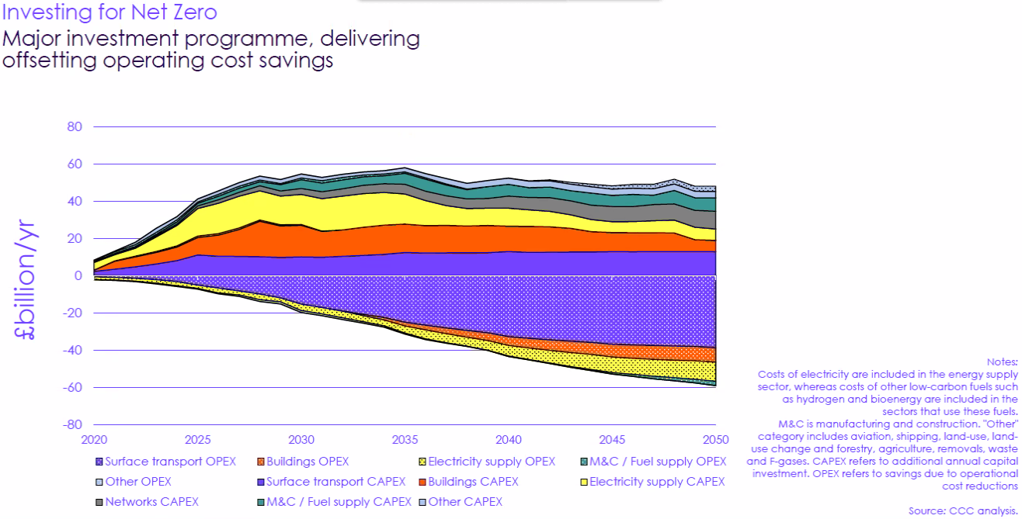
By 2050 the savings will balance out the level of investment.
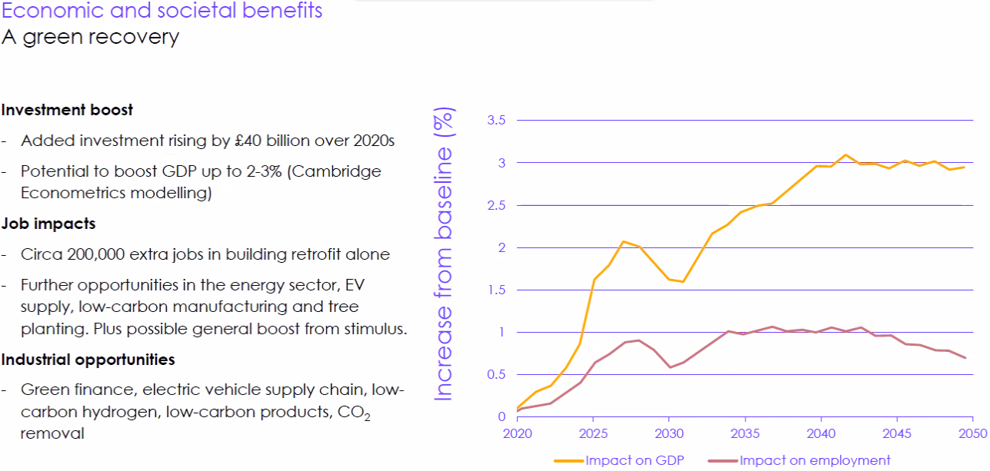
A lot of the investment is in imported fossil fuels. Therefore savings will be ongoing. The winners possibly do not know they are
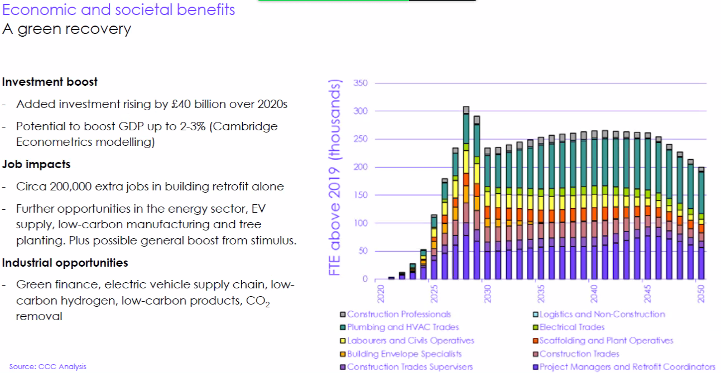
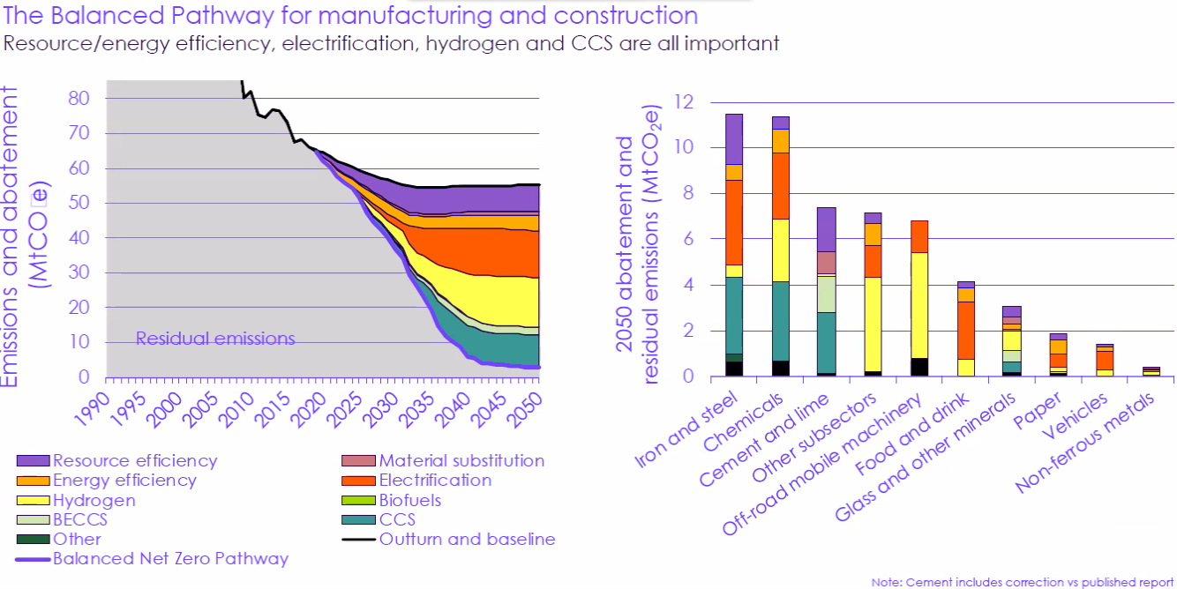
This approach is balanced but is reliant on some aspects of each element in each sector
Electrification will probably need grid enhancement and there is a need for a hydrogen grid.
It is better to prevent offshoring as it could be a net increase in emissions.
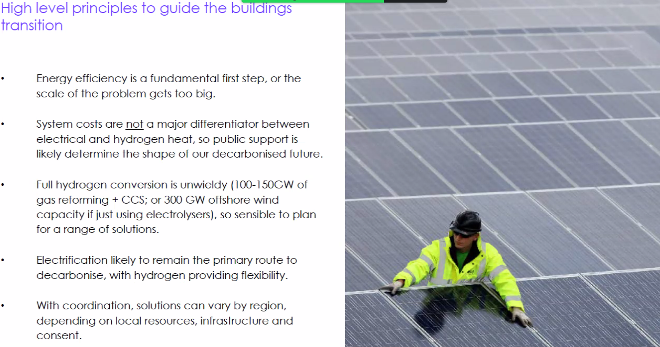
Electrification is available now whilst hydrogen heating may be problematic. But there are pros and cons and a regional approach is needed.
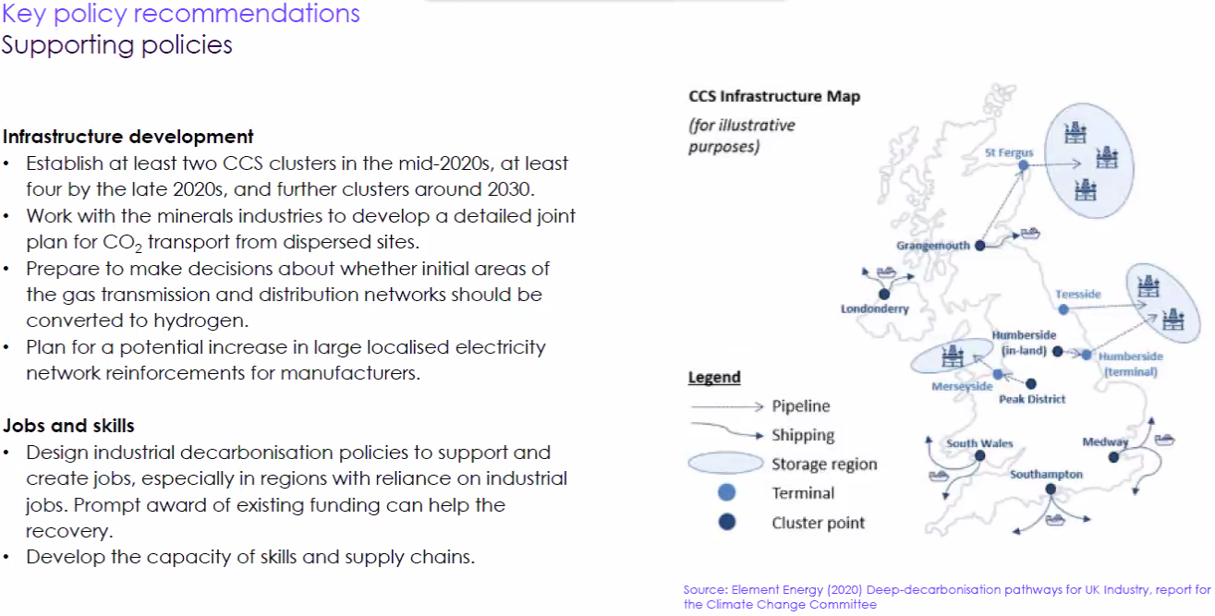
The CCC believes that whilst there are options re mineralisation and the use of deep mines as storage facilities but there is a public engagement issue here to ensure that they accept that there is very low risk with on shore storage options.

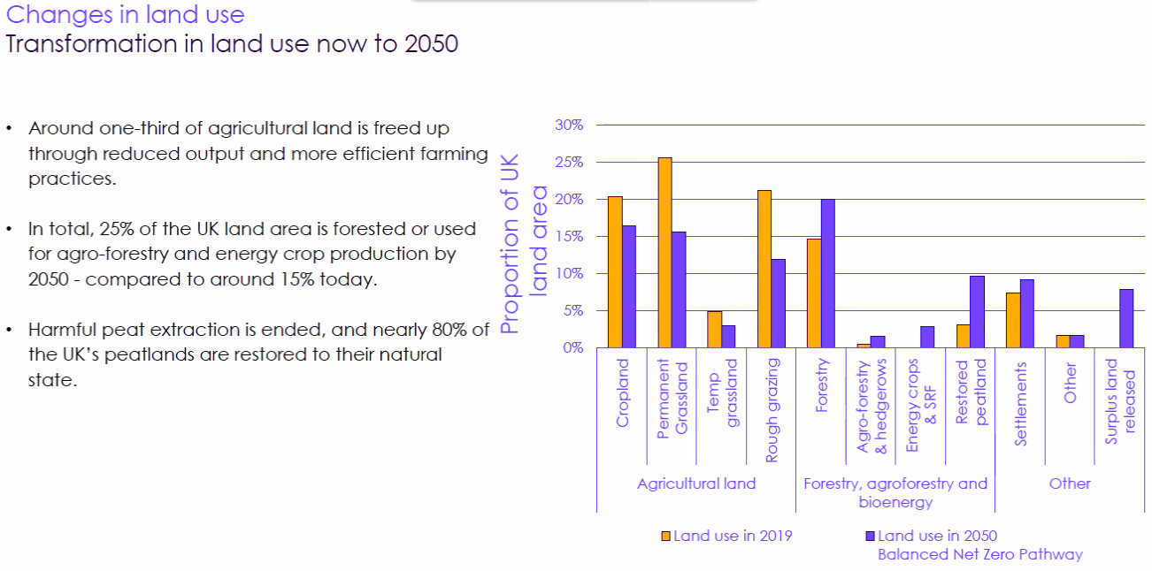
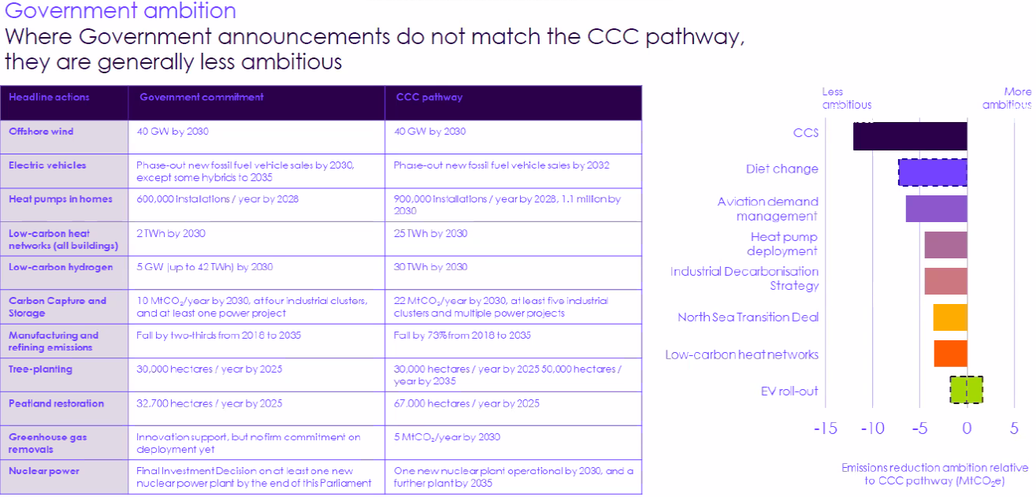
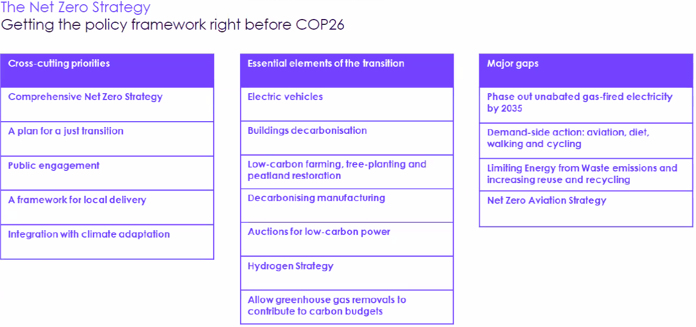
They believe that the only transport area that will use a refinery going forward would be aviation in 2050. By 2050 all surface transport will need to be fossil fuel free.
2035 unabated electricity generation needed but no commitments from government yet.
The CCC believes that the government needs to provide a far narrower approach re the solutions.

